Class Diagram

A report describing the Class Diagrams for the Network Appliance Service Utilisation Framework

Version: 0.1

By

Paul Fergus

Supervised by

Dr. Martin Hanneghan and Prof. Madjid Merabti

Networked Appliances Lab
School of Computing and Mathematical Sciences
Liverpool John Moores University

Table of Contents
Table of Contents ii
Table of Figures ix
1 Introduction 2
1.1 Sections 2
1.2 Release Information 2
1.3 Reader Level 2
1.4 The Specification Process 3
1.5 Version Information 3
1.6 Referenced Documents 3
2 The Unified Modelling Language – Class Diagrams Overview 4
2.1 Class Diagrams 4
2.2 Classes 5
2.3 Interfaces 5
2.4 Collaborations 5
2.5 Relationships 5
2.5.1 Dependencies 5
2.5.2 Generalisation 6
2.5.3 Association 6
2.5.4 Aggregation 6
2.5.5 Composition 6
3 Class Diagram: Distributed Semantic Unstructured Services (DiSUS) Manager 8
3.1 Description 8
3.2 Issues 8
3.3 Requirements 8
3.4 Assumptions 8
3.5 Attributes 9
3.6 Methods 9
3.7 Extensions 10
4 Class Diagram: P2P Implementation 13
4.1 Description 13
4.2 Issues 13
4.3 Requirements 13
4.4 Assumptions 13
4.5 Attributes 13
4.6 Methods 14
4.7 Extensions 14
5 Class Diagram: Discovery Service 15
5.1 Description 15
5.2 Issues 15
5.3 Requirements 15
5.4 Assumptions 15
5.5 Attributes 15
5.6 Methods 15
5.7 Extensions 16
6 Class Diagram: Endpoint Service 19
6.1 Description 19
6.2 Issues 19
6.3 Requirements 19
6.4 Assumptions 19
6.5 Attributes 19
6.6 Methods 20
6.7 Extensions 20
7 Class Diagram: Endpoint 21
7.1 Description 21
7.2 Issues 21
7.3 Requirements 21
7.4 Assumptions 21
7.5 Attributes 21
7.6 Methods 21
7.7 Extensions 22
8 Class Diagram: Service Implementation Manager 23
8.1 Description 23
8.2 Issues 23
8.3 Requirements 23
8.4 Assumptions 23
8.5 Attributes 23
8.6 Methods 23
8.7 Extensions 24
9 Class Diagram: Peer Service Manager 25
9.1 Description 25
9.2 Issues 25
9.3 Requirements 25
9.4 Assumptions 25
9.5 Attributes 25
9.6 Methods 26
9.7 Extensions 26
10 Class Diagram: Peer Service Advertisement 27
10.1 Description 27
10.2 Issues 27
10.3 Requirements 27
10.4 Assumptions 27
10.5 Attributes 27
10.6 Methods 27
10.7 Extensions 28
11 Class Diagram: Service Class Advertisement 29
11.1 Description 29
11.2 Issues 29
11.3 Requirements 29
11.4 Assumptions 29
11.5 Attributes 30
11.6 Methods 30
11.7 Extensions 30
12 Class Diagram: Service Specification Advertisement 31
12.1 Description 31
12.2 Issues 31
12.3 Requirements 31
12.4 Assumptions 31
12.5 Attributes 32
12.6 Methods 32
12.7 Extensions 32
13 Class Diagram: Service Implementation Advertisement 33
13.1 Description 33
13.2 Issues 33
13.3 Requirements 34
13.4 Assumptions 34
13.5 Attributes 34
13.6 Methods 34
13.7 Extensions 34
14 Class Diagram: Service Ontology Model 35
14.1 Description 35
14.2 Issues 35
14.3 Requirements 35
14.4 Assumptions 35
14.5 Attributes 35
14.6 Methods 36
14.7 Extensions 36
15 Class Diagram: Service Profile Ontology Model 37
15.1 Description 37
15.2 Issues 37
15.3 Requirements 37
15.4 Assumptions 37
15.5 Attributes 37
15.6 Methods 38
15.7 Extensions 38
16 Class Diagram: Service Process Ontology Model 39
16.1 Description 39
16.2 Issues 39
16.3 Requirements 39
16.4 Assumptions 39
16.5 Attributes 39
16.6 Methods 39
16.7 Extensions 40
17 Class Diagram: Service Grounding Ontology Model 41
17.1 Description 41
17.2 Issues 41
17.3 Requirements 41
17.4 Assumptions 41
17.5 Attributes 41
17.6 Methods 42
17.7 Extensions 42
18 Class Diagram: Service Interface Model 43
18.1 Description 43
18.2 Issues 43
18.3 Requirements 43
18.4 Assumptions 43
18.5 Attributes 43
18.6 Methods 44
18.7 Extensions 44
19 Class Diagram: Device Capability Advertisement 45
19.1 Description 45
19.2 Issues 45
19.3 Requirements 45
19.4 Assumptions 45
19.5 Attributes 45
19.6 Methods 45
19.7 Extensions 46
20 Class Diagram: Context Template Service 47
20.1 Description 47
20.2 Issues 47
20.3 Requirements 47
20.4 Assumptions 47
20.5 Attributes 47
20.6 Methods 48
20.7 Extensions 48
21 Class Diagram: Context Template 49
21.1 Description 49
21.2 Issues 49
21.3 Requirements 49
21.4 Assumptions 49
21.5 Attributes 49
21.6 Methods 49
21.7 Extensions 50
22 Class Diagram: Distributed Emergent Semantics (DistrES) Service 51
22.1 Description 51
22.2 Issues 51
22.3 Requirements 51
22.4 Assumptions 51
22.5 Attributes 51
22.6 Methods 52
22.7 Extensions 52
23 Class Diagram: Concept Extractor Engine Service 53
23.1 Description 53
23.2 Issues 53
23.3 Requirements 53
23.4 Assumptions 53
23.5 Attributes 53
23.6 Methods 54
23.7 Extensions 54
24 Class Diagram: Evolutionary Pattern Extraction Engine Service 55
24.1 Description 55
24.2 Issues 55
24.3 Requirements 55
24.4 Assumptions 55
24.5 Attributes 55
24.6 Methods 56
24.7 Extensions 56
25 Class Diagram: DistrES Ontology 57
25.1 Description 57
25.2 Issues 57
25.3 Requirements 57
25.4 Assumptions 57
25.5 Attributes 57
25.6 Methods 58
25.7 Extensions 58
26 Class Diagram: Semantic Interoperability and Signature Matching (SISM) Service 59
26.1 Description 59
26.2 Issues 59
26.3 Requirements 59
26.4 Assumptions 59
26.5 Attributes 59
26.6 Methods 59
26.7 Extensions 60
27 Class Diagram: Abstract Matcher Service 61
27.1 Description 61
27.2 Issues 61
27.3 Requirements 61
27.4 Assumptions 61
27.5 Attributes 61
27.6 Methods 62
27.7 Extensions 62
28 Class Diagram: Concrete Matcher Service 63
28.1 Description 63
28.2 Issues 63
28.3 Requirements 63
28.4 Assumptions 63
28.5 Attributes 63
28.6 Methods 64
28.7 Extensions 64
29 References 65

Table of Figures
Figure 1 UML Notation for a Class Diagram 4
Figure 2 Distributed Semantic Unstructured Services Manager 8
Figure 3 P2P Implementation Classes 13
Figure 4 Discovery Service 15
Figure 5 Endpoint Service 19
Figure 6 Endpoint 21
Figure 7 Service Implementation Manager 23
Figure 8 Peer Service Manager 25
Figure 9 Peer Service Advertisement 27
Figure 10 Service Class Advertisement 29
Figure 11 Service Specification Advertisement 31
Figure 12 Service Implementation Advertisement 33
Figure 13 Service Ontology Model 35
Figure 14 Service Profile Ontology Model 37
Figure 15 Service Process Ontology Model 39
Figure 16 Service Grounding Ontology Model 41
Figure 17 Service Interface Model 43
Figure 18 Device Capability Advertisement 45
Figure 19 Context Template Service 47
Figure 20 Context Template 49
Figure 21 Distributed Emergent Semantics Service 51
Figure 22 Extractor Engine Service 53
Figure 23 Evolutionary Pattern Extraction Engine Service 55
Figure 24 DistrES Ontology 57
Figure 25 Semantic Interoperability and Signature Matching Service 59
Figure 26 Abstract Matcher Service 61
Figure 27 Concrete Matcher Service 63

ABSTRACT
User demands and technological advances are driving the complex integration between heterogeneous devices, and moving us closer to pervasive and ubiquitous computing environments. The home of the future will include an embedded ‘intelligence’ and accommodate a flexible integration of services to perform functions that are only limited by our imagination. The family car and working environment will be closely integrated allowing the children to watch a movie on digital screens embedded in the back of the driver and passenger seats, by directly streaming the digital content from the DVD player located in the living room of your home. Furthermore you will be able to access and listen to music stored on your MP3 player, which you accordingly left at the office on Friday night, via your wireless enabled headphones, without interrupting the children’s viewing experience. This vision will expose the functionalities offered by devices as independent services [1] and capitalise on advances made in global communications to revolutionise the way we interact with the plethora of devices that surround us.
This vision will require us to perceive and interact with our devices in ways we have never experienced before. The constraints placed on us by manufacturers and service providers will become a thing of the past as the flexible and seamless integration of distributed devices become common place. One of the challenges is to expose the functions offered by devices as services. Manufactures will need to re-engineer most common household appliances and produce solutions that better utilise the functionalities a particular device offers. A framework needs to be developed that allows services to be described using machine-processible semantics enabling devices to make informed decisions regarding the composition process once a potential service has been discovered. The framework needs to utilise advances made in Peer-to-Peer technologies and provide discovery mechanisms that ensure collaborations between devices encompass vocabularies that support machine-level understanding.
In this report we describe how we have designed the Networked Appliance Service Utilisation Framework (NASUF) including the Distributed Semantic Unstructured Services (DiSUS) [2] protocol, the Distributed Emergent Semantics (DistrES) algorithm [3] and the Semantic Interoperability and Signature Matching (SISM) algorithms [4]. We explain how NASUF implements the DiSUS protocol to publish and discover unstructured services within P2P networks, the DistrES algorithm to manage and evolve ontological information over time based on general consensus, and the SISM algorithm to dynamically compose services and resolve terminology differences that occur.

Introduction
The Network Appliance Service Utilisation Framework (NASUF) is designed to allow service-enabled devices to be seamlessly integrated within Peer-to-Peer (P2P) networks. Once these devices have been deployed they can expose the functions they provide as independent services, which are described and discovered using machine-processable semantics.
The framework is flexible and does not place any constraints on the underlying technologies used. It is designed to provide a set of core interfaces that must be implemented in order to enable services to be effectively described and discovered within P2P networks. This framework does not place any constraints on the underlying communication protocols used or the P2P technology used to deploy devices and the services they provide. Furthermore it does not place any constraints on the service technology used allowing a plethora of different services to be used and integrated with relative ease.
This is the first release of this specification and is still a work in progress. Its primary goal is to define a set of generic interfaces that support the above mentioned requirements.

Sections
This document is split into two sections. The first section provides a conceptual overview of UML [5] and Class Diagram modelling within UML. It describes the vocabulary used and provides some simple illustrations that show a simple Class Diagram. The second section provides a detailed list of all the Class Diagrams used to define this framework.

Release Information
This document is a work in progress and is an initial first draft. This release is an unstable release that is designed to prompt discussions in order to refine our overall framework design. Its primary function is to highlight the functionalities this framework provides and to prompt further investigation.

Reader Level
This document can be used by a number of readers, who are concerned with the framework from a number of different viewpoints.
- Service Developers
- Distributed Computing Developers
- Semantic Web Developers
- Networked Appliance Developers
- Framework Designers
- Enterprise Architects
This specification assumes that the reader is converse with UML and more specifically Class Diagram design. The specification is language and protocol agnostic and could be used to implement service-enabled networked appliances using a number of different languages, which implement a number of different communication protocols.

The Specification Process
The specification process is performed as part of a PhD project, with a number of researchers and Academic staff involved in its creation. The specification is reviewed subject matter experts within the fields of UML modelling, P2P technologies, Semantic Web technologies and Networked Appliances. We hope that as this specification evolves it will be opened up to a much wider audience, whereby contributions can be made by a number of expert groups.
The current process involves the framework design using a number of UML models. At predetermined millstones the designs are submitted to the subject matter experts, which are then evaluated. Any changes are performed and all design decisions are challenged. This process continues until defined work packages are completed.

Version Information
This version is not designed to be used for implementations. This version is designed to prompt discussion on this framework design to ensure that the framework captures all the required functionality.

Referenced Documents
The following documents should be read in conjunction with this Class Diagram document.
- NASUF – Use Case Diagram 1.0.doc
- NASUF – Activity Diagram 1.0.doc
- NASUF – Sequence Diagram 1.0.doc

The Unified Modelling Language – Class Diagrams Overview
This document defines all the Class Diagrams that exist within the NASUF framework. As a result this section only concerns itself with Class Diagram modelling. Other UML models are discussed in relevant documents that should be read in conjunction with this document as detailed in Section 1.6 above.

Class Diagrams
If you look around your immediate environment, you will see a number of “Things”. These things will have a number of attributes (properties) and a number of behaviours (operations). You will also be able to deduce that these “Things” belong to certain categories. For example the chair you are sitting on belongs to the “Furniture” category and the person sat next to you belongs to the “Human Being” category. In object oriented programming we refer to these categories as classes. A class can be viewed as a group of things that have similar attributes and posses similar behaviours. For example a class of dog has a tail (attribute) and it barks (behaviour). A class in UML is represented as a square, which contains the class name, its associated properties and the behaviours it has.

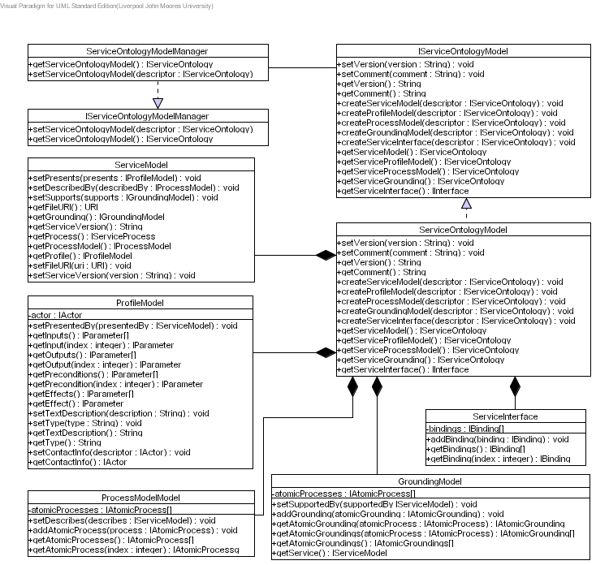
Figure 1 UML Notation for a Class Diagram
The class itself is split into three sections; the top area contains the name of the class, the middle contains the attributes and the bottom contains the operations supported by the class.
It is important that we think about classes of things and the attributes and operations they support because it is easier to simulate a complex real-world environment when we represent classes as real-world things. Furthermore classes help the analyst by allowing them to talk to clients using terminology they understand, which stimulates the client to reveal important details about the problems they want to solve.

Classes
The name of a class is by convention, a word with its first letter capitalised. As illustrated in Figure 5, it appears near the top of the rectangle. If your class has a two-word name, join the two words together and capitalise the first letter of each word, for example AudioDevice.

Interfaces
After you’ve created a number of classes, you might notice they’re not related to a particular parent, but their behaviours might include some of the same operations with the same signatures (parameters you pass to the operation). You can code the operations for one of the classes and reuse them in the others. Another possibility is that you develop a set of operations for classes in one system, and reuse them for classes in another. Either way you will want to capture the reusable set of operations. The interface is the UML construct that enables you to do this. An interface is a set of operations that specifies something about a class’s behaviour. Think of an interface as a class that only has operations - no attributes. The interface is a set of operations that a class presents to other classes.
Instead of using a new element to represent an interface, you can use a class icon with <<Interface>> situated just above the class name.

Collaborations
To identify the collaborations, we need to study the responsibilities of a class and determine what other classes the object interacts with. In short, what other classes does this object need to perform all its required responsibilities and complete its job? As you examine the collaborations, you might find that you have missed some necessary classes or that some classes that you initially identified are not needed. To help discover collaborations Use Case scenarios can be used. For each Use Case, identify the objects and the messages that they exchange. You may want to create collaboration diagrams to document this step.
Obviously there can be an infinite number of scenarios. The purpose of this part of the process is not to document all possible scenarios, which is obviously an impossible task. The real purpose of creating Use Case scenarios is to help you define the choice of your classes and their responsibilities. By examining the collaborations you might identify an important class that you missed.

Relationships

Dependencies
A dependency is a type of relationship, whereby one class uses another class. The most common usage of a dependency is to show that the signature of one class’s operation uses another class. Suppose you are designing a system that displays corporate forms onscreen, so employees can fill them out. The employee uses a menu to select the form to fill out. In your design, you have a System class and a Form class. Among its many operations, the System class has displayForm(f:Form). The form the system displays obviously depends on which form the user selects. The UML notation for this is a dotted line with an arrow head.

Generalisation
One of the interesting features of object oriented design is the close relationship with the common-sense aspects of day-to-day life: For example if you know something about an appliance then you know that it has an on and off switch or button. Furthermore it has a brand name and a unique serial number. Another example may be a family pet such as a cat. You know that it meows, catches birds and plays with mice. You also know that it is a mammal, it sleeps, it is mobile and it has to eat at various times of the day.
A lot of these properties are generic to a lot of animals. For example a dog and a monkey are also mammals – they also sleep and move from one location to anther (mobile). Moving more generic features to super classes provides generalised features to be inherited by more specific objects in a typical classification tree. Object-orientation refers to this as inheritance. In UML this is referred to as generalisation. This means that one class (the child class or a subclass) can inherit attributes and operations from anther class (known as the parent class or a superclass). The parent class is a more general class than its child class.

Association
Objects do not exist in isolation but rather they have relationships with other objects. Objects that are conceptually connected to each other in this way are called associations. For example, when you turn on your television, a relationship exists between you and the television. When you turn the television on you have a unidirectional (one-way) association with the television.
Other associations exist which are bidirectional, for example when you marry someone you have an association called “is married to” which can be used in either direction between two objects, i.e. John is married to Lisa and Lisa is married to John.
Associations are not just limited to unidirectional and bidirectional relationships but can also have multiple associations. An object might be associated with another object in more than one way. For example if you and a colleague at work are friends then you have a “is a friend of” association as well as a “is a co-worker of” association.

Aggregation
There are many examples of aggregation that exist within our real-world environment. For example a car consists of doors, a bonnet, a boot, wheels, a steering wheel and windows. The combination of these objects is known as an aggregation. This is another type of association between objects and in this instance, means that the car is made from a number of objects. Aggregation is purely conceptual, and does no more than to distinguish the whole from its parts. Aggregation does not change the meaning of associations. Therefore, aggregation between a component class and an aggregate class is equivalent to a general association among the involved classes.

Composition
Another type of association is called composition, which is similar to Aggregation. Both composition and aggregation are used for modelling a “whole/part” relationship in which one class represents the “whole” that consists of smaller things (the “parts”). Composition has a stronger meaning than aggregation. Composition is a form of aggregation where the lifetime of the parts depends on the lifetime of the whole (i.e. the parts may be created after the whole, and can also be explicitly removed before the whole, however, if the whole is destroyed, then the parts die with it). Because of that, the multiplicity of a composite end, (unlike an aggregate end), must always be at the most one (i.e., it cannot be shared by different instances of the owner class).

Class Diagram: Distributed Semantic Unstructured Services (DiSUS) Manager

Description
This Class Diagram illustrates the classes used to implement distributed semantic unstructured services within this framework. The Class Diagram is illustrated in Figure 2.
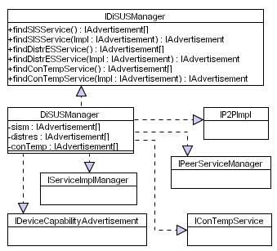
Figure 2 Distributed Semantic Unstructured Services Manager

Issues
The issues associated with the Class Diagram are not known at this stage.

Requirements
The DiSUSManager class must form part of the bootstrap software that allows the device to discover and bind to all the core services required within this framework. The DiSUSManager class must implement the IDiSUSManager, the IP2PImpl, the IPeerServiceManager, the IDeviceCapabilityAdvertisement, the IConTempService, and the IServiceImplManager interfaces. The IDiSUSManager interface provides a set of methods that allows the device to discover all the core services required within this framework. The IP2PImpl provides a set of methods that allows the device to discover the required P2P services and join the P2P network. The IPeerServiceManager allows the device to create and publish all the core and application specific peer services provided by the device. The IServiceImplManager interface allows the service container to be started and implementation services to be published within the service container – this is dependant on the service technology being used. The IDeviceCapabilityAdvertisement interface allows the device capabilities to be created and published locally and remotely within the P2P network. All these interfaces and the methods they provide must be implemented – the code details within each method are left to the device manufacturer.

Assumptions
The assumptions for this Class Diagram are not known at this stage of the design.

Attributes
This Class Diagram supports several classes with each class containing zero or more attributes. Each of these attributes are listed and described below.
Class | Attribute | Description
DiSUSManager | sism | There will be several SISM services within the P2P network, which will be provided by other devices connected to the network, consequently a service request will result in several advertisements being returned. This attribute will contain all the service advertisements returned. This collection allows alternative services to be used in the advent of a particular service within the collection becoming unavailable.
DiSUSManager | distres | There will be several DistrES services within the P2P network, which will be provided by other devices connected to the network, consequently a service request will result in several advertisements being returned. This attribute will contain all the service advertisements returned. This collection allows alternative services to be used in the advent of a particular service within the collection becoming unavailable.
DiSUSManager | conTemp | There will be several ConTemp services within the P2P network, which will be provided by other devices connected to the network, consequently a service request will result in several advertisements being returned. This attribute will contain all the service advertisements returned. This collection allows alternative services to be used in the advent of a particular service within the collection becoming unavailable.
Table 1 DiSUS Attributes

Methods
This Class Diagram supports several classes with each class containing zero or more methods. Each of these methods are listed and described below.
Class | Method | Description
DiSUSManager | findSISMManager | This method propagates a service request for SISM Services. After some pre-determined time this method returns a collection of IAdvertisments for each service discovered. This collection of advertisements is added to the sism attribute.
DiSUSManager | findDistrESManager | This method propagates a service request for DistrES Services. After some pre-determined time this method returns a collection of IAdvertisments for each service discovered. This collection of advertisements is added to the distres attribute.
DiSUSManager | findConTempService | This method propagates a service request for ConTemp Services. After some pre-determined time this method returns a collection of IAdvertisments for each service discovered. This collection of advertisements is added to the conTemp attribute.
Table 2 DiSUS Methods

Extensions
There are no known extensions for this Class Diagram at this stage of the design.

Class Diagram: Peer Service

Description
This Class Diagram illustrates the required Peer Service class, including its associated subclasses which must be used within this framework. The Class Diagram is illustrated in Figure 4.
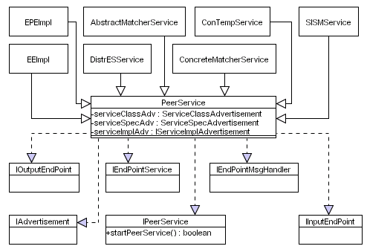
Figure 3 Peer Service

Issues
The issues associated with the Class Diagram are not known at this stage.

Requirements
This is a service oriented middleware, which consists of several core services and zero or more application specific services. All these services are peer services. The peer service class has several subclassed services that implement the core functionality within the framework. The peer service must implement several interfaces in order to allow each peer service to expose the functionality the peer service provides using an end point address. The peer service and its associated subclasses must allow devices to explicitly implement the core functionality required within this framework. It is not mandatory that the device explicitly implements all the core peer services, however unimplemented peer services will have to be discovered and used remotely within the P2P network.

Assumptions
Each peer service has three service advertisements – the information to create these advertisements must be passed as a parameter to the peer service constructor.

Attributes
This Class Diagram supports several classes with each class containing zero or more attributes. Each of these attributes are listed and described below.
Class | Attribute | Description
PeerService | serviceClassAdv | This attribute contains the service class advertisement for the peer service – only one service class advertisement per peer service is allowed.
PeerService | serviceSpecAdv | This attribute contains the service specification advertisements for each peer service – only one service specification advertisement per peer service is allowed.
PeerService | serviceImplAdv | This attribute contains the service implementation advertisement for each peer – only one service implementation advertisement per peer service is allowed.
Table 3 Peer Service Attributes

Methods
This class diagram supports several classes with each class containing zero or more methods. Each of these methods are listed and described below.
Class | Method | Description
IPeerService | startPeerService | This method allows the peer service to be started. In this instance the endpoint used by the peer service will be started allowing the service to receive messages from within the P2P network. Once a service has been created and the service advertisements have been created and published, the peer service must be started.
Table 4 Peer Service Methods

Extensions
There are no known extensions for this Class Diagram at this stage of the design.

Class Diagram: P2P Implementation

Description
This Class Diagram illustrates what the required P2P implementation classes needed within this framework. The Class Diagram is illustrated in Figure 4.
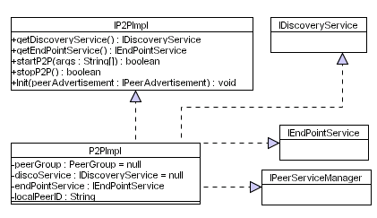
Figure 4 P2P Implementation

Issues
The issues associated with the Class Diagram are not known at this stage.

Requirements
The P2P implementation class enables the device to be connected to the P2P network. It allows the device to publish the functions the device provides. It also allows the device to discover services provided by other devices within the P2P network. This class must implement the discovery service and the endpoint service. The discovery service must allow the device to propagate and receive messages within the network and the endpoint service allows the device to host the peer services it provides on the network. This class must also implement the IPeerServiceManager to create and start the peer services the device provides.

Assumptions
The assumptions for this Class Diagram are not known at this stage of the design.

Attributes
This Class Diagram supports several classes with each class containing zero or more attributes. Each of these attributes are listed and described below.
Class | Attribute | Description
P2PImpl | peerGroup | This attribute is a string that contains the name of the peer group the device belongs to. The device will use this peer group name to connect to the P2P network when it is first started.
P2PImpl | discoService | This attribute contains a binding to a particular discover service implementation used within the P2P network. This binding allows the device to receive and propagate messages within the P2P network.
P2PImpl | endPointService | This attribute contains a binding to a particular endpoint service implementation used within the P2P network. This binding allows endpoints to be created and associated with individual peer services.
P2PImpl | localPeerID | This is the peers local unique ID that uniquely identifies the device on the network.
Table 5 P2P Implementation Attributes

Methods
This class diagram supports several classes with each class containing zero or more methods. Each of these methods are listed and described below.
Class | Method | Description
IP2PImpl | getDiscoveryService | This method retrieves the discovery service from the P2P implementation. The return value from this is assigned to the discoService attribute.
IP2PImpl | getEndPointService | This method retrieves the endpoint service from the P2P implementation. The return value from this is assigned to the endPointService attribute.
IP2PImpl | startP2P | This method starts the P2P implementation. It allows the device to connect to the network and authenticate itself.
IP2PImpl | stopP2P | This method stops the P2P implementation. It allows the device to disconnect itself from the network.
IP2PImpl | init | This method allows the device to perform any initialisation functions required before it joins the network.
Table 6 P2P Implementation Methods

Extensions
There are no known extensions for this Class Diagram at this stage of the design.

Class Diagram: Discovery Service

Description
This Class Diagram illustrates the classes required for the discovery service used within this framework. The Class Diagram is illustrated in Figure 5.
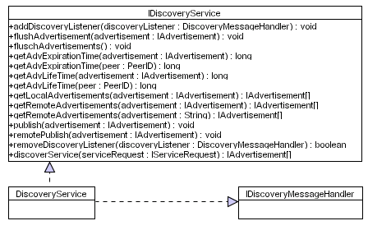
Figure 5 Discovery Service

Issues
The issues associated with the Class Diagram are not known at this stage.

Requirements
The discovery service classes provide the underlying messaging system within this framework. It must allow devices to propagate messages within the P2P network in order to advertise peer services they provide and/or discover peer services they require. The discovery mechanisms must allow the device to flush advertisements from the local cache, whether this is a manual process or an automated process, as well as allow the device to query information about existing advertisements it has. It must also allow the device to publish its own advertisements locally and remotely within the P2P network. Advertisements, whether they are local or remote must also be discovered using the Discovery Service. The IDiscoveryService class must implement the IDiscoveryMessageHandler, which allows asynchronous message passing between peer services.

Assumptions
The assumptions at this stage are that the Discovery Service will send and receive XML messages within the P2P network. Depending on what type of information is trying to be discovered, will depend on the message structure being propagated. xxx

Attributes
This class diagram supports several classes with each class containing zero or more attributes. Each of these attributes are listed and described below.
Class | Attribute | Description
NA | NA | NA
Table 7 Discovery Service Attributes

Methods
This class diagram supports several classes with each class containing zero or more methods. Each of these methods are listed and described below.
Class | Method | Description
IDiscoveryService | addDiscoveryListener
IDiscoveryService | flushAdvertisements
IDiscoveryService | getAdvExpirationTime
IDiscoveryService | getAdvLifeTime
IDiscoveryService | getLocalAdvertisements
IDiscoveryService | getRemoteAdvertisements
IDiscoveryService | publish
IDiscoveryService | remotePublish
IDiscoveryService | removeDiscoveryListener
IDiscoveryService | discoverService
Table 8 DiSUS Class Diagram Methods

Extensions
There are no known extensions for this Class Diagram at this stage of the design.

Class Diagram: Discovery Event

Description
This Class Diagram illustrates the classes required for the discovery service used within this framework. The Class Diagram is illustrated in Figure 5.
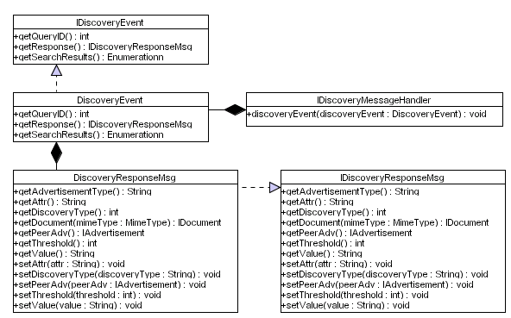
Figure 6 Discovery Event

Issues
The issues associated with the Class Diagram are not known at this stage.

Requirements
The requirements for this Class Diagram are not known at this stage of the design.

Assumptions
The assumptions for this Class Diagram are not known at this stage of the design.

Attributes
This class diagram supports several classes with each class containing zero or more attributes. Each of these attributes are listed and described below.
Class | Attribute | Description
Table 9 DiSUS Class Diagram Attributes

Methods
This class diagram supports several classes with each class containing zero or more methods. Each of these methods are listed and described below.
Class | Method | Description
Table 10 DiSUS Class Diagram Methods

Extensions
There are no known extensions for this Class Diagram at this stage of the design.

Class Diagram: Endpoint Service

Description
This Class Diagram illustrates the classes required for the endpoint service used within this framework. The Class Diagram is illustrated in Figure 7.
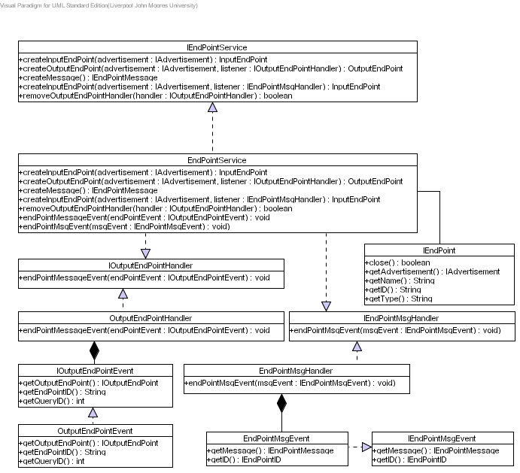
Figure 7 Endpoint Service

Issues
The issues associated with the Class Diagram are not known at this stage.

Requirements
The requirements for this Class Diagram are not known at this stage of the design.

Assumptions
The assumptions for this Class Diagram are not known at this stage of the design.

Attributes
This class diagram supports several classes with each class containing zero or more attributes. Each of these attributes are listed and described below.
Class | Attribute | Description
Table 11 DiSUS Class Diagram Attributes

Methods
This class diagram supports several classes with each class containing zero or more methods. Each of these methods are listed and described below.
Class | Method | Description
Table 12 DiSUS Class Diagram Methods

Extensions
There are no known extensions for this Class Diagram at this stage of the design.

Class Diagram: Endpoint

Description
This Class Diagram illustrates the classes required for the Endpoints using within this framework. The Class Diagram is illustrated in Figure 8.
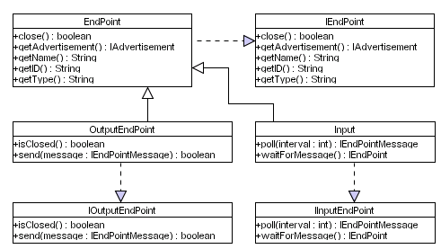
Figure 8 Endpoint

Issues
The issues associated with the Class Diagram are not known at this stage.

Requirements
The requirements for this Class Diagram are not known at this stage of the design.

Assumptions
The assumptions for this Class Diagram are not known at this stage of the design.

Attributes
This class diagram supports several classes with each class containing zero or more attributes. Each of these attributes are listed and described below.
Class | Attribute | Description
Table 13 DiSUS Class Diagram Attributes

Methods
This class diagram supports several classes with each class containing zero or more methods. Each of these methods are listed and described below.
Class | Method | Description
Table 14 DiSUS Class Diagram Methods

Extensions
There are no known extensions for this Class Diagram at this stage of the design.

Class Diagram: Service Implementation Manager

Description
This Class Diagram illustrates the classes required for the implementation service manager within this framework. The Class Diagram is illustrated in Figure 9.
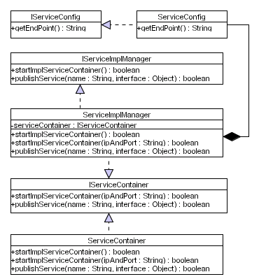
Figure 9 Service Implementation Manager

Issues
The issues associated with the Class Diagram are not known at this stage.

Requirements
The requirements for this Class Diagram are not known at this stage of the design.

Assumptions
The assumptions for this Class Diagram are not known at this stage of the design.

Attributes
This class diagram supports several classes with each class containing zero or more attributes. Each of these attributes are listed and described below.
Class | Attribute | Description
Table 15 DiSUS Class Diagram Attributes

Methods
This class diagram supports several classes with each class containing zero or more methods. Each of these methods are listed and described below.
Class | Method | Description
Table 16 DiSUS Class Diagram Methods

Extensions
There are no known extensions for this Class Diagram at this stage of the design.

Class Diagram: Peer Service Manager

Description
This Class Diagram illustrates the classes required for the Peer Service Manager within this framework. The Class Diagram is illustrated in Figure 10.
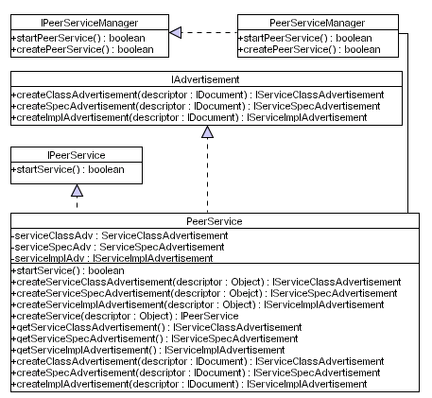
Figure 10 Peer Service Manager

Issues
The issues associated with the Class Diagram are not known at this stage.

Requirements
The requirements for this Class Diagram are not known at this stage of the design.

Assumptions
The assumptions for this Class Diagram are not known at this stage of the design.

Attributes
This class diagram supports several classes with each class containing zero or more attributes. Each of these attributes are listed and described below.
Class | Attribute | Description
Table 17 DiSUS Class Diagram Attributes

Methods
This class diagram supports several classes with each class containing zero or more methods. Each of these methods are listed and described below.
Class | Method | Description
Table 18 DiSUS Class Diagram Methods

Extensions
There are no known extensions for this Class Diagram at this stage of the design.

Class Diagram: Peer Service Advertisement

Description
This Class Diagram illustrates the required classes to create peer service advertisements within this framework. The Class Diagram is illustrated in Figure 11.
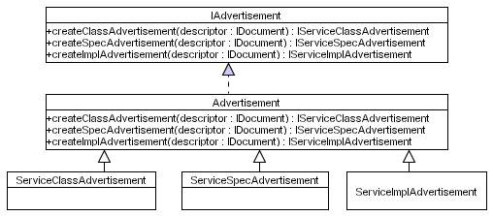
Figure 11 Peer Service Advertisement

Issues
The issues associated with the Class Diagram are not known at this stage.

Requirements
The requirements for this Class Diagram are not known at this stage of the design.

Assumptions
The assumptions for this Class Diagram are not known at this stage of the design.

Attributes
This class diagram supports several classes with each class containing zero or more attributes. Each of these attributes are listed and described below.
Class | Attribute | Description
Table 19 DiSUS Class Diagram Attributes

Methods
This class diagram supports several classes with each class containing zero or more methods. Each of these methods are listed and described below.
Class | Method | Description
Table 20 DiSUS Class Diagram Methods

Extensions
There are no known extensions for this Class Diagram at this stage of the design.

Class Diagram: Service Class Advertisement

Description
This Class Diagram illustrates the classes required to create a service class advertisement within this framework. The Class Diagram is illustrated in Figure 12.
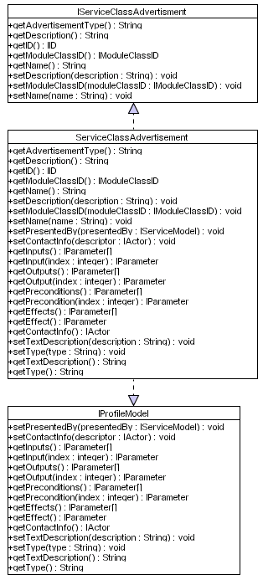
Figure 12 Service Class Advertisement

Issues
The issues associated with the Class Diagram are not known at this stage.

Requirements
The requirements for this Class Diagram are not known at this stage of the design.

Assumptions
The assumptions for this Class Diagram are not known at this stage of the design.

Attributes
This class diagram supports several classes with each class containing zero or more attributes. Each of these attributes are listed and described below.
Class | Attribute | Description
Table 21 DiSUS Class Diagram Attributes

Methods
This class diagram supports several classes with each class containing zero or more methods. Each of these methods are listed and described below.
Class | Method | Description
Table 22 DiSUS Class Diagram Methods

Extensions
There are no known extensions for this Class Diagram at this stage of the design.

Class Diagram: Service Specification Advertisement

Description
This Class Diagram illustrates the required classes to create a service specification advertisement within this framework. The Class Diagram is illustrated in Figure 13.
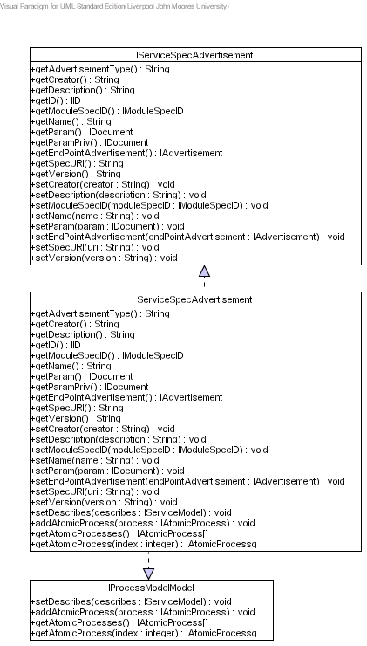
Figure 13 Service Specification Advertisement

Issues
The issues associated with the Class Diagram are not known at this stage.

Requirements
The requirements for this Class Diagram are not known at this stage of the design.

Assumptions
The assumptions for this Class Diagram are not known at this stage of the design.

Attributes
This class diagram supports several classes with each class containing zero or more attributes. Each of these attributes are listed and described below.
Class | Attribute | Description
Table 23 DiSUS Class Diagram Attributes

Methods
This class diagram supports several classes with each class containing zero or more methods. Each of these methods are listed and described below.
Class | Method | Description
Table 24 DiSUS Class Diagram Methods

Extensions
There are no known extensions for this Class Diagram at this stage of the design.

Class Diagram: Service Implementation Advertisement

Description
This Class Diagram illustrates the required classes to create a service implementation service within this framework. The Class Diagram is illustrated in Figure 14.
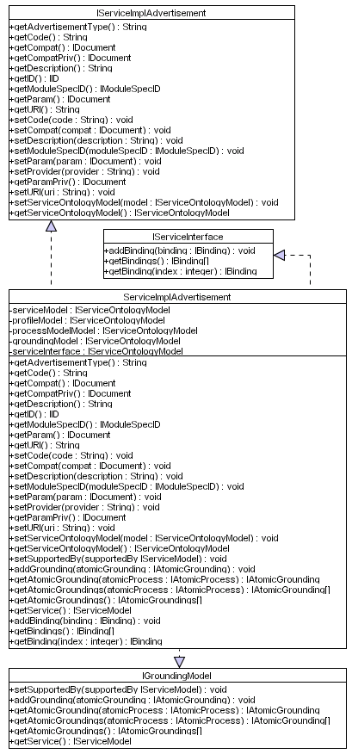
Figure 14 Service Implementation Advertisement

Issues
The issues associated with the Class Diagram are not known at this stage.

Requirements
The requirements for this Class Diagram are not known at this stage of the design.

Assumptions
The assumptions for this Class Diagram are not known at this stage of the design.

Attributes
This class diagram supports several classes with each class containing zero or more attributes. Each of these attributes are listed and described below.
Class | Attribute | Description
Table 25 DiSUS Class Diagram Attributes

Methods
This class diagram supports several classes with each class containing zero or more methods. Each of these methods are listed and described below.
Class | Method | Description
Table 26 DiSUS Class Diagram Methods

Extensions
There are no known extensions for this Class Diagram at this stage of the design.

Class Diagram: Service Ontology Model

Description
This Class Diagram illustrates the required classes to service ontology model within this framework. The Class Diagram is illustrated in Figure 15.
Figure 15 Service Ontology Model

Issues
The issues associated with the Class Diagram are not known at this stage.

Requirements
The requirements for this Class Diagram are not known at this stage of the design.

Assumptions
The assumptions for this Class Diagram are not known at this stage of the design.

Attributes
This class diagram supports several classes with each class containing zero or more attributes. Each of these attributes are listed and described below.
Class | Attribute | Description
Table 27 DiSUS Class Diagram Attributes

Methods
This class diagram supports several classes with each class containing zero or more methods. Each of these methods are listed and described below.
Class | Method | Description
Table 28 DiSUS Class Diagram Methods

Extensions
There are no known extensions for this Class Diagram at this stage of the design.

Class Diagram: Service Profile Ontology Model

Description
This Class Diagram illustrates the required classes need to create a service profile ontology model within this framework. The Class Diagram is illustrated in Figure 16.
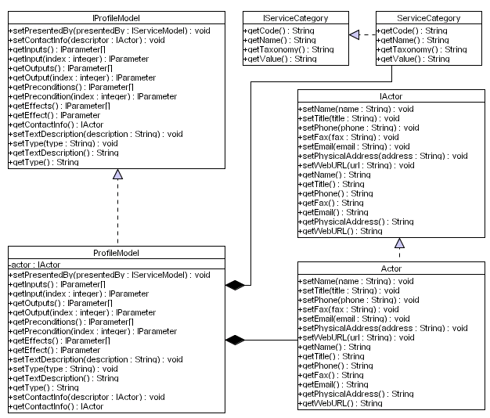
Figure 16 Service Profile Ontology Model

Issues
The issues associated with the Class Diagram are not known at this stage.

Requirements
The requirements for this Class Diagram are not known at this stage of the design.

Assumptions
The assumptions for this Class Diagram are not known at this stage of the design.

Attributes
This class diagram supports several classes with each class containing zero or more attributes. Each of these attributes are listed and described below.
Class | Attribute | Description
Table 29 DiSUS Class Diagram Attributes

Methods
This class diagram supports several classes with each class containing zero or more methods. Each of these methods are listed and described below.
Class | Method | Description
Table 30 DiSUS Class Diagram Methods

Extensions
There are no known extensions for this Class Diagram at this stage of the design.

Class Diagram: Service Process Ontology Model

Description
This Class Diagram illustrates the classes required to create a service process ontology model within this framework. The Class Diagram is illustrated in Figure 17.
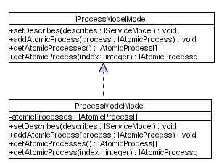
Figure 17 Service Process Ontology Model

Issues
The issues associated with the Class Diagram are not known at this stage.

Requirements
The requirements for this Class Diagram are not known at this stage of the design.

Assumptions
The assumptions for this Class Diagram are not known at this stage of the design.

Attributes
This class diagram supports several classes with each class containing zero or more attributes. Each of these attributes are listed and described below.
Class | Attribute | Description
Table 31 DiSUS Class Diagram Attributes

Methods
This class diagram supports several classes with each class containing zero or more methods. Each of these methods are listed and described below.
Class | Method | Description
Table 32 DiSUS Class Diagram Methods

Extensions
There are no known extensions for this Class Diagram at this stage of the design.

Class Diagram: Service Grounding Ontology Model

Description
This Class Diagram illustrates the classes required to create a service process ontology model within this framework. The Class Diagram is illustrated in Figure 18.
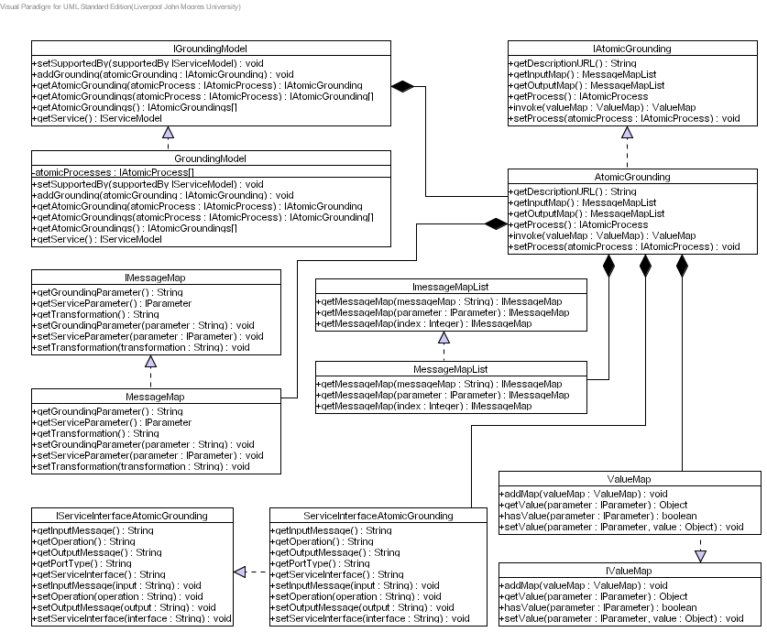
Figure 18 Service Grounding Ontology Model

Issues
The issues associated with the Class Diagram are not known at this stage.

Requirements
The requirements for this Class Diagram are not known at this stage of the design.

Assumptions
The assumptions for this Class Diagram are not known at this stage of the design.

Attributes
This class diagram supports several classes with each class containing zero or more attributes. Each of these attributes are listed and described below.
Class | Attribute | Description
Table 33 DiSUS Class Diagram Attributes

Methods
This class diagram supports several classes with each class containing zero or more methods. Each of these methods are listed and described below.
Class | Method | Description
Table 34 DiSUS Class Diagram Methods

Extensions
There are no known extensions for this Class Diagram at this stage of the design.

Class Diagram: Service Interface Model

Description
This Class Diagram illustrates the classes required to create a service interface model within this framework. The Class Diagram is illustrated in Figure 19.
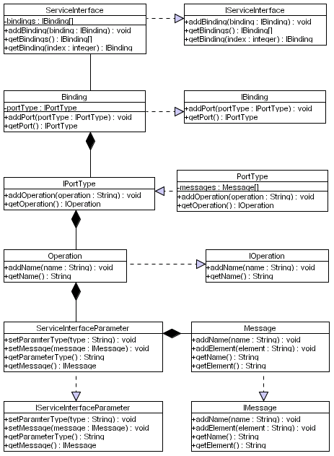
Figure 19 Service Interface Model

Issues
The issues associated with the Class Diagram are not known at this stage.

Requirements
The requirements for this Class Diagram are not known at this stage of the design.

Assumptions
The assumptions for this Class Diagram are not known at this stage of the design.

Attributes
This class diagram supports several classes with each class containing zero or more attributes. Each of these attributes are listed and described below.
Class | Attribute | Description
Table 35 DiSUS Class Diagram Attributes

Methods
This class diagram supports several classes with each class containing zero or more methods. Each of these methods are listed and described below.
Class | Method | Description
Table 36 DiSUS Class Diagram Methods

Extensions
There are no known extensions for this Class Diagram at this stage of the design.

Class Diagram: Device Capability Advertisement

Description
This Class Diagram illustrates the classes required to create a device capability advertisement within this framework. The Class Diagram is illustrated in Figure 20.
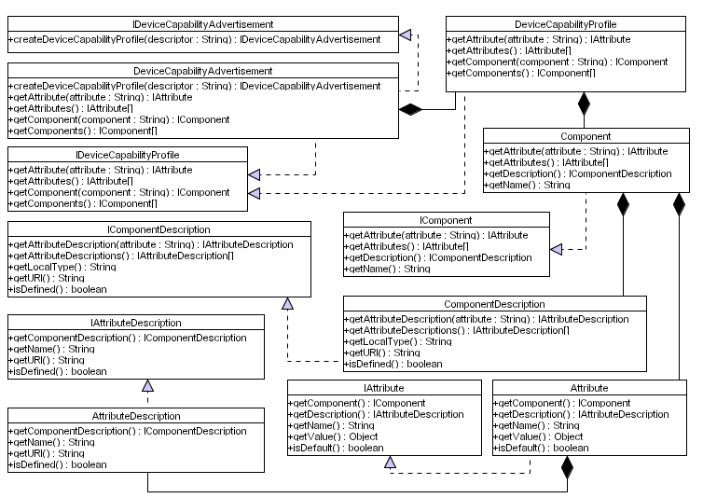
Figure 20 Device Capability Advertisement

Issues
The issues associated with the Class Diagram are not known at this stage.

Requirements
The requirements for this Class Diagram are not known at this stage of the design.

Assumptions
The assumptions for this Class Diagram are not known at this stage of the design.

Attributes
This class diagram supports several classes with each class containing zero or more attributes. Each of these attributes are listed and described below.
Class | Attribute | Description
Table 37 DiSUS Class Diagram Attributes

Methods
This class diagram supports several classes with each class containing zero or more methods. Each of these methods are listed and described below.
Class | Method | Description
Table 38 DiSUS Class Diagram Methods

Extensions
There are no known extensions for this Class Diagram at this stage of the design.

Class Diagram: Context Template Service

Description
This Class Diagram illustrates the classes required to create a device capability advertisement within this framework. The Class Diagram is illustrated in Figure 20.
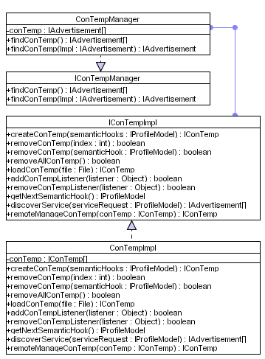
Figure 21 Context Template Service

Issues
The issues associated with the Class Diagram are not known at this stage.

Requirements
The requirements for this Class Diagram are not known at this stage of the design.

Assumptions
The assumptions for this Class Diagram are not known at this stage of the design.

Attributes
This class diagram supports several classes with each class containing zero or more attributes. Each of these attributes are listed and described below.
Class | Attribute | Description
Table 39 DiSUS Class Diagram Attributes

Methods
This class diagram supports several classes with each class containing zero or more methods. Each of these methods are listed and described below.
Class | Method | Description
Table 40 DiSUS Class Diagram Methods

Extensions
There are no known extensions for this Class Diagram at this stage of the design.

Class Diagram: Context Template

Description
This Class Diagram illustrates the classes required to create a device capability advertisement within this framework. The Class Diagram is illustrated in Figure 20.
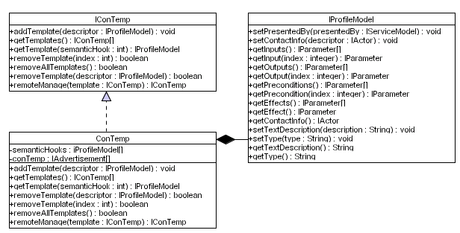
Figure 22 Context Template

Issues
The issues associated with the Class Diagram are not known at this stage.

Requirements
The requirements for this Class Diagram are not known at this stage of the design.

Assumptions
The assumptions for this Class Diagram are not known at this stage of the design.

Attributes
This class diagram supports several classes with each class containing zero or more attributes. Each of these attributes are listed and described below.
Class | Attribute | Description
Table 41 DiSUS Class Diagram Attributes

Methods
This class diagram supports several classes with each class containing zero or more methods. Each of these methods are listed and described below.
Class | Method | Description
Table 42 DiSUS Class Diagram Methods

Extensions
There are no known extensions for this Class Diagram at this stage of the design.

Class Diagram: Distributed Emergent Semantics (DistrES) Service

Description
This Class Diagram illustrates the classes required for implementing distributed emergent semantics within this framework. The Class Diagram is illustrated in Figure 23.
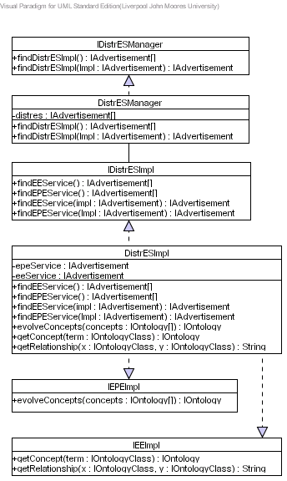
Figure 23 Distributed Emergent Semantics Service

Issues
The issues associated with the Class Diagram are not known at this stage.

Requirements
The requirements for this Class Diagram are not known at this stage of the design.

Assumptions
The assumptions for this Class Diagram are not known at this stage of the design.

Attributes
This class diagram supports several classes with each class containing zero or more attributes. Each of these attributes are listed and described below.
Class | Attribute | Description
Table 43 DiSUS Class Diagram Attributes

Methods
This class diagram supports several classes with each class containing zero or more methods. Each of these methods are listed and described below.
Class | Method | Description
Table 44 DiSUS Class Diagram Methods

Extensions
There are no known extensions for this Class Diagram at this stage of the design.

Class Diagram: Concept Extractor Engine Service

Description
This Class Diagram illustrates the classes required for the extracting concepts from the knowledge base within this framework. The Class Diagram is illustrated in Figure 24.
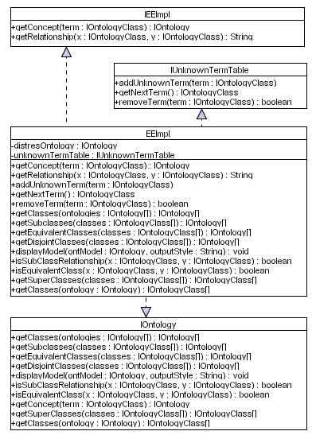
Figure 24 Extractor Engine Service

Issues
The issues associated with the Class Diagram are not known at this stage.

Requirements
The requirements for this Class Diagram are not known at this stage of the design.

Assumptions
The assumptions for this Class Diagram are not known at this stage of the design.

Attributes
This class diagram supports several classes with each class containing zero or more attributes. Each of these attributes are listed and described below.
Class | Attribute | Description
Table 45 DiSUS Class Diagram Attributes

Methods
This class diagram supports several classes with each class containing zero or more methods. Each of these methods are listed and described below.
Class | Method | Description
Table 46 DiSUS Class Diagram Methods

Extensions
There are no known extensions for this Class Diagram at this stage of the design.

Class Diagram: Evolutionary Pattern Extraction Engine Service

Description
This Class Diagram illustrates the classes required to extract common patterns and evolve knowledge structures within this framework. The Class Diagram is illustrated in Figure 25.
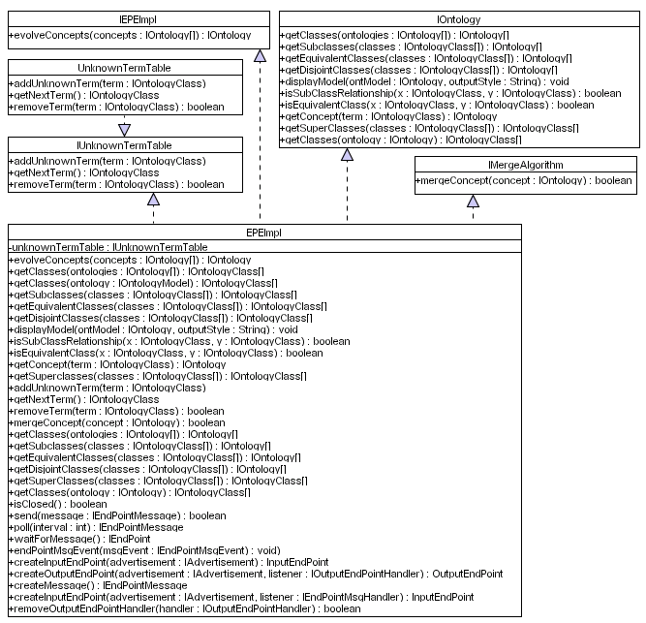
Figure 25 Evolutionary Pattern Extraction Engine Service

Issues
The issues associated with the Class Diagram are not known at this stage.

Requirements
The requirements for this Class Diagram are not known at this stage of the design.

Assumptions
The assumptions for this Class Diagram are not known at this stage of the design.

Attributes
This class diagram supports several classes with each class containing zero or more attributes. Each of these attributes are listed and described below.
Class | Attribute | Description
Table 47 DiSUS Class Diagram Attributes

Methods
This class diagram supports several classes with each class containing zero or more methods. Each of these methods are listed and described below.
Class | Method | Description
Table 48 DiSUS Class Diagram Methods

Extensions
There are no known extensions for this Class Diagram at this stage of the design.

Class Diagram: DistrES Ontology

Description
This Class Diagram illustrates the classes required to describe ontologies within this framework. The Class Diagram is illustrated in Figure 26.
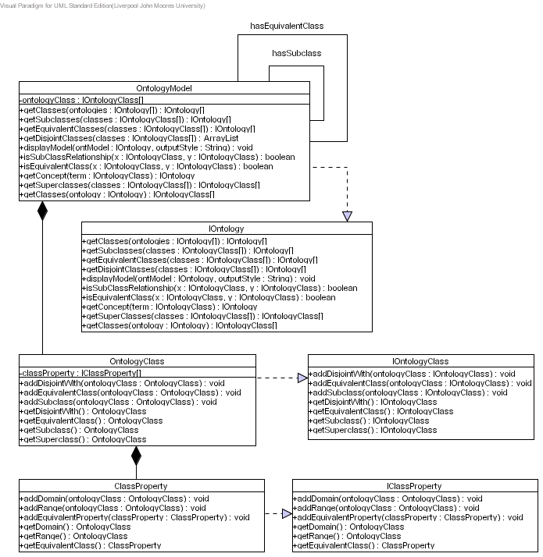
Figure 26 DistrES Ontology

Issues
The issues associated with the Class Diagram are not known at this stage.

Requirements
The requirements for this Class Diagram are not known at this stage of the design.

Assumptions
The assumptions for this Class Diagram are not known at this stage of the design.

Attributes
This class diagram supports several classes with each class containing zero or more attributes. Each of these attributes are listed and described below.
Class | Attribute | Description
Table 49 DiSUS Class Diagram Attributes

Methods
This class diagram supports several classes with each class containing zero or more methods. Each of these methods are listed and described below.
Class | Method | Description
Table 50 DiSUS Class Diagram Methods

Extensions
There are no known extensions for this Class Diagram at this stage of the design.

Class Diagram: Semantic Interoperability and Signature Matching (SISM) Service

Description
This Class Diagram illustrates the required classes for performing semantic interoperability. The Class Diagram is illustrated in Figure 27.
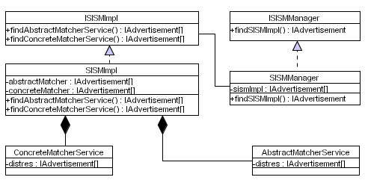
Figure 27 Semantic Interoperability and Signature Matching Service

Issues
The issues associated with the Class Diagram are not known at this stage.

Requirements
The requirements for this Class Diagram are not known at this stage of the design.

Assumptions
The assumptions for this Class Diagram are not known at this stage of the design.

Attributes
This class diagram supports several classes with each class containing zero or more attributes. Each of these attributes are listed and described below.
Class | Attribute | Description
Table 51 DiSUS Class Diagram Attributes

Methods
This class diagram supports several classes with each class containing zero or more methods. Each of these methods are listed and described below.
Class | Method | Description
Table 52 DiSUS Class Diagram Methods

Extensions
There are no known extensions for this Class Diagram at this stage of the design.

Class Diagram: Abstract Matcher Service

Description
This Class Diagram illustrates the classes required to abstract match service requests with service descriptions. The Class Diagram is illustrated in Figure 28.
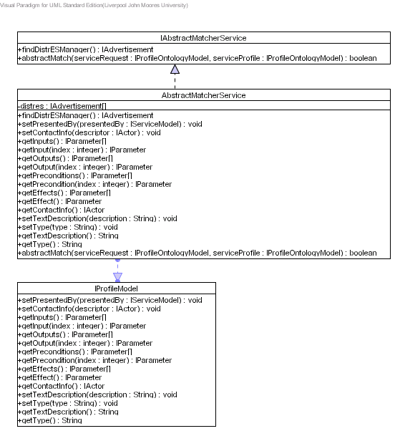
Figure 28 Abstract Matcher Service

Issues
The issues associated with the Class Diagram are not known at this stage.

Requirements
The requirements for this Class Diagram are not known at this stage of the design.

Assumptions
The assumptions for this Class Diagram are not known at this stage of the design.

Attributes
This class diagram supports several classes with each class containing zero or more attributes. Each of these attributes are listed and described below.
Class | Attribute | Description
Table 53 DiSUS Class Diagram Attributes

Methods
This class diagram supports several classes with each class containing zero or more methods. Each of these methods are listed and described below.
Class | Method | Description
Table 54 DiSUS Class Diagram Methods

Extensions
There are no known extensions for this Class Diagram at this stage of the design.

Class Diagram: Concrete Matcher Service

Description
This Class Diagram illustrates the required classes to concrete match service descriptions with signatures in service interfaces. The Class Diagram is illustrated in Figure 29.
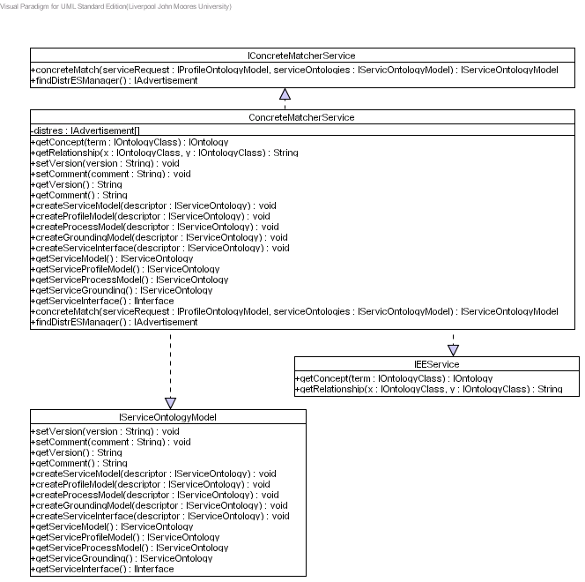
Figure 29 Concrete Matcher Service

Issues
The issues associated with the Class Diagram are not known at this stage.

Requirements
The requirements for this Class Diagram are not known at this stage of the design.

Assumptions
The assumptions for this Class Diagram are not known at this stage of the design.

Attributes
This class diagram supports several classes with each class containing zero or more attributes. Each of these attributes are listed and described below.
Class | Attribute | Description
Table 55 DiSUS Class Diagram Attributes

Methods
This class diagram supports several classes with each class containing zero or more methods. Each of these methods are listed and described below.
Class | Method | Description
Table 56 DiSUS Class Diagram Methods

Extensions
There are no known extensions for this Class Diagram at this stage of the design.

References

